**#FunTimesWithTheTA   
Inspire – a “Do-It-Yourself” Respiration Sensor**

Adapted from: <http://www.instructables.com/id/Heart-Sensor-With-AutoAdjusted-Threshold-and-Heart/> by Orlando S. Hoilett

**Introduction**

In this installment of #FunTimesWithTheTA we will build Inspire a “Do-It-Yourself” Respiration Sensor. With Inspire, we will be able to collect a photoplethysmogram from a person’s finger, plot the waveform, and calculate respiration rate. Additionally, we are going to add a simple circuit that automatically detects when inhalation is occurring and will activate a LED meter in response.

**Objectives**

* Understand the modification of the photoplethysmograph (Figure 1) to get the respiration signal
* Understand the operation of photodiodes for detecting light
* Understand the basics of filters, different filter types, cutoff frequency
* Understand the terms pass band, stop band, attenuation, and filter
* Understand the application of time constant to different circuit configurations including peak detectors
* Understand the use of comparators to create the LED meter
* ***Have some FUN! FUN! FUN!***

**ABET Outcomes**

“an ability to function effectively on a team whose members together provide leadership, create a collaborative and inclusive environment, establish goals, plan tasks, and meet objectives” (Outcome 5)

“an ability to develop and conduct appropriate experimentation, analyze and interpret data, and use engineering judgment to draw conclusions” (Outcome 6)

“an ability to acquire and apply new knowledge as needed, using appropriate learning strategies.” (Outcome 7)

http://www.abet.org/accreditation/accreditation-criteria/criteria-for-accrediting-

engineering-programs-2018-2019/

Photoplethysmography is the study of the change of volume in an organ using light. Photoplethysmography has famously been applied to measuring the volume of blood in someone’s finger (or other periphery such as a toe or earlobe) as a method of calculating heart rate. In this technique, the finger is illuminated by a light-emitting diode (LED) (often red, IR, or green) and a photodetector measures the amount of light that passes through the finger. The intensity of light that passes through the finger varies with respiration, this has a characteristic waveform (Figure 1).

There are two major types of photoplethysmography that are used in the real-world. These two types are transmission photoplethysmography and reflectance photoplethysmography. In the transmission case, we are detecting the amount of light that passes through a person’s finger. In the reflectance case, we are detecting the amount of light that reflects from the finger. Reflectance photoplethysmography is famously employed by smartwatches and other fitness trackers, while transmission photoplethysmography is used in the clinic and is probably the most utilized of the two techniques. You may be familiar with the [finger pulse oximeter](https://www.google.com/search?q=finger+pulse+oximeter&num=30&newwindow=1&source=lnms&tbm=isch&sa=X&ved=0ahUKEwiArbL8p8jWAhXhxlQKHaI8BHAQ_AUICygC&biw=1280&bih=652) used by nurses in a clinical setting to collect heart rate and blood oxygen data from a patient. We will be using reflectance-mode finger photoplethysmography for this lesson.

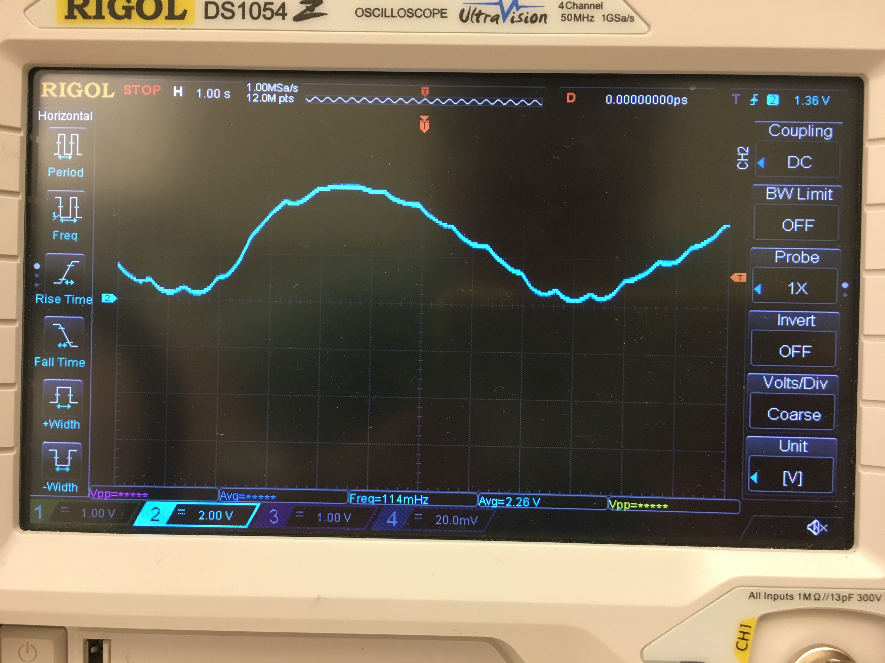

Exhalation

Inhalation

*Figure 1: Example Respiration Signal of Inspire. (Ignore the exact output voltages)*



*Figure 2: Circuit diagram of Inspire.*

**Table of Contents**

|  |  |
| --- | --- |
| **Section** | **Page** |
| Introduction | **1** |
| Objectives | **1** |
| Inspire Schematic | **2** |
| Part #1: Transducer: The Light-Emitting Diode and the Photodiode | **4** |
| Part #2: Transimpedance Amplifier (TIA) and Low Pass Filter | **6** |
| Part #3: Active High Pass Filter | **8** |
| Part #4: Adaptive Peak Detector and LED Meter | **10** |
| Additional Inspire Schematic | **15** |
| Revision History | **16** |

**Part #1: Transducer: The Light-Emitting Diode and the Photodiode**

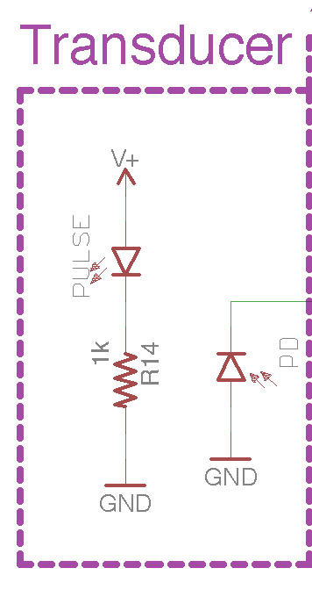

*Figure 3: LED and Photodiode.*

***Red Light-Emitting Diode (LED)***

LEDs are light-emitting diodes. These are a special class of diodes that light up when powered. For respiration, really any color LED can be used. Red, IR (infrared), and green are most common for photoplethysmography since they are often employed in pulse oximeters and commercial smartwatches. Red and IR LEDs are often employed in pulse oximeters for measuring blood oxygen. Green LEDs are heavily used by smartwatches and fitness trackers as green has been reported to pass through thicker tissue, like the wrist, better than red and IR light.

As mentioned earlier, LEDs are diodes, so the polarity of the LED is important. The anode is the positive side of the LED, while the cathode is the negative side. For ease of use, the anode usually has a longer pin than the cathode.

***Photodiode***

Photodiodes are handy circuit components that convert light energy into electrical current. Photodiodes allow us to measure the amount of light that reflects off the finger and convert the light energy into current.

Photodiodes come in many varieties. The photodiode we will be using is the BPV10, a standard PIN diode with decent light sensitivity and responsivity. The BPV10 is sensitive to the entire visible spectrum, so we must be careful to prevent excessive ambient light from affecting our measurements. The rest of our circuit has been designed to filter out changes in the signal due to ambient light, but please be aware that we may need to do a few more modifications nonetheless. Just like the LED, a photodiode also has a polarity. Be sure that you connect the photodiode’s anode to ground. Unlike LEDs, we actually intentionally connect the photodiode backwards. In this configuration, however, the photodiode is zero-biased and will be operating in photoconductive mode.

We will be placing the LED and photodiode snuggly in a perfboard. Finger photoplethysmography is very sensitive to movement noise. Placing the LED and photodiode in a fixed platform will help remove movement noise.

***Instructions***

1. Place the LED and photodiode into the perfboard. They should be able to fit side-by-side.
2. Solder the two components onto the perfboard
3. Cut the perfboard to size to remove empty space.

***Testing:***

1. Power the LED with 5 V. It should light up.

**NOTE:** LED brightness increases with increasing current. Please limit the current through the LED to about 30mA.

**Part #2: Transimpedance Amplifier (TIA) and Low Pass Filter**

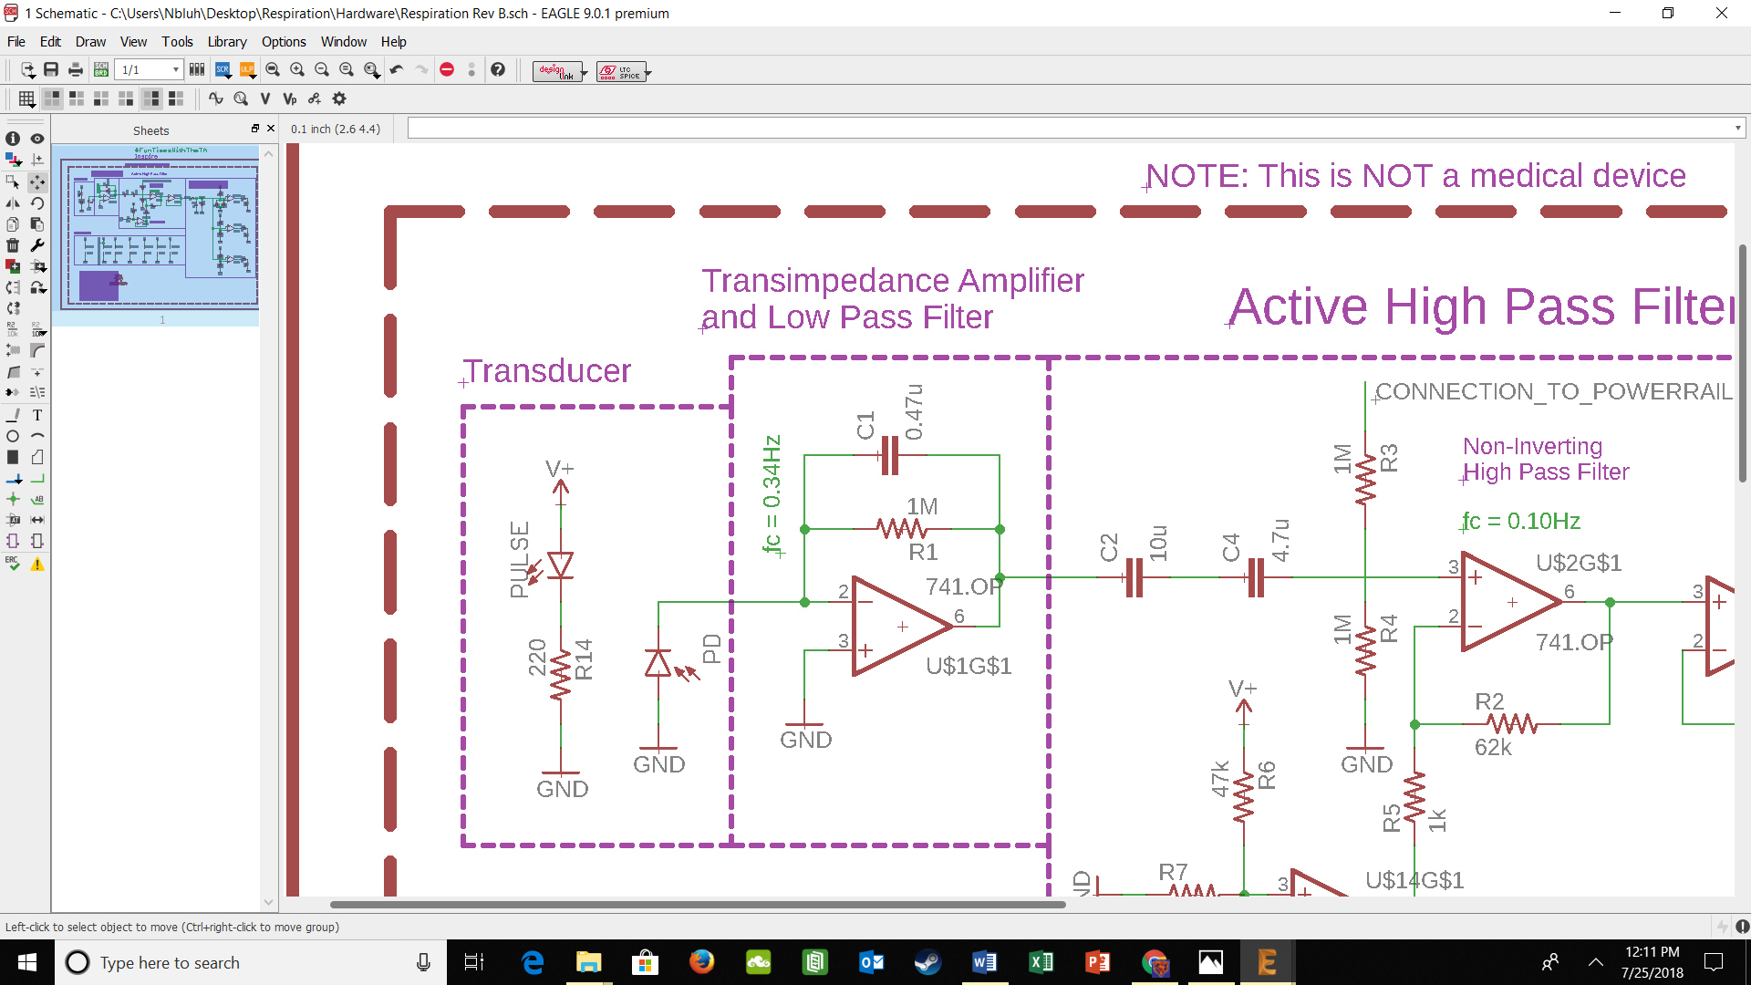*Figure 4: Transimpedance Amplifier (TIA) or “current-to-voltage” converter and Low Pass Filter. The photodiode is in a zero-bias state. When light hits the photodiode, it produces a current that is converted to a voltage using the TIA. The output voltage of the TIA should be positive, increasing from zero with increasing LED light intensity.*

A transimpedance amplifier (TIA) is a “current-to-voltage” converter that converts the current produced by the photodiode, to a voltage that can be read at the output of the amplifier. This occurs because of Kirchhoff’s Current Law. The current produced by the photodiode flows away from the inverting pin of the op amp to ground. KCL says that whatever current flows out of the node, must also flow into the node. As such, we get an equal and opposite current through RF and CF. Ohm’s Law says that V = I*ZF (where ZF is the equivalent impedance of RF and CF), which results in a voltage at the output of the amplifier that is proportional to the photocurrent.

Additionally, CF and RF create a low-pass filter with a cut-off frequency defined by

$f_{c}=1/{2πR_{F}C_{F}}$ (2)

RF for a transimpedance circuit is typically very large, which means that our TIA has a very high gain. High gain in an amplifier can often cause unstable behavior known as “oscillations”. CF helps dampen high frequency oscillations by creating a low-pass filter with RF. We will set the “cut-off” frequency of our low-pass filter to 0.34Hz. The frequency of our respiration waveform should be between 0.1 and 0.3Hz, so this is more than sufficient for filtering out high frequency noise without attenuating frequencies of our respiration waveform, very much.

Additionally, the gain of our TIA is defined by the following equation (if we ignore the effect of CF inside of our passband), where IP is the photodiode photocurrent and RF is the feedback resistance:

$V_{out}=-I_{P}*R_{F}$ (3)

Using equation 3, we can calculate the output voltage of our amplifier given a certain photocurrent and feedback resistance. If your op amp is saturating, please reduce the value of your feedback resistance. You should take care to modify your capacitor value as well to maintain the same cutoff frequency.

***Testing:***

1. Power the TIA with +/-5V from the benchtop power supply
2. Use your oscilloscope to view the output of the TIA.
3. Repeatedly block and un-block the photodiode, preventing the light from hitting the photodiode, by placing an opaque object between the two components. You should see a changing output similar to a square wave. The difference may only be a few tens of milliVolts.

***Try It!***

1. Place your finger on the photodiode and LED.
2. Adjust the gain of the TIA amplifier so that its output is around 1 Volt.

**NOTE:** For adjusting the gain at this stage, I would recommend increasing or decreasing the brightness of the LED first, before changing the gain of the TIA. If you do adjust the feedback resistor of the TIA amplifier, please remember to adjust the capacitor value as well. I would recommend keeping a cutoff frequency of around 0.34Hz.

**Part #3: Active High Pass Filter**

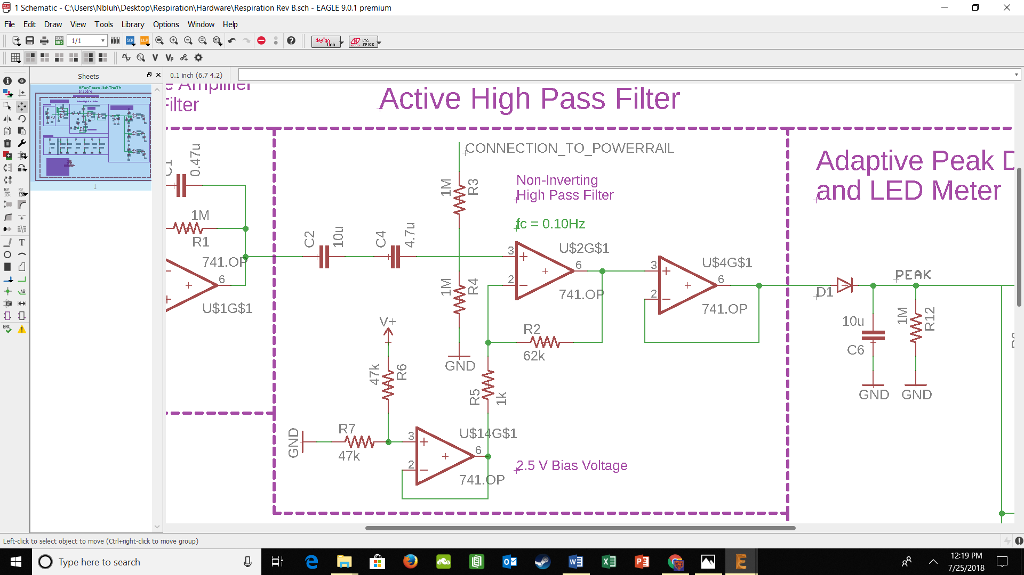

*Figure 5: Active High Pass Filter to provide gain and decrease noise.*

A high pass filter is a useful filter configuration that allows us to attenuate frequencies below a given cutoff frequency. Recall from equation 1 that the cut-off frequency of low-pass and high-pass filters are determined by

$f_{c}=1/{2πR_{F}C_{F}}$ (2)

The low-pass filter determines the higher cut-off frequency. The high-pass filter determines the lower cut-off frequency.

***Testing***

1. Power the op amps with +/-5V from the benchtop power supply
2. Create a 0.1 Hz, 1 Vpp sine wave from your function generator in High-Z mode.
3. Input the sine wave into your high pass filter.
4. Record your output peak-to-peak voltage
5. Change your frequency to 0.5Hz. Note your output peak-to-peak voltage. This voltage should be larger than the 0.2Hz signal.

**NOTE:** If you adjust the gain of the filter, you should change the resistors if you can, but do not decrease it to lower than 680Ohms. If you need to change a resistor, make sure you adjust the capacitor to ensure the cutoff frequency of the filter is maintained. If you adjust the gain of the amplifier, do so by changing the resistor alone.

**Part #4: Adaptive Peak Detector**

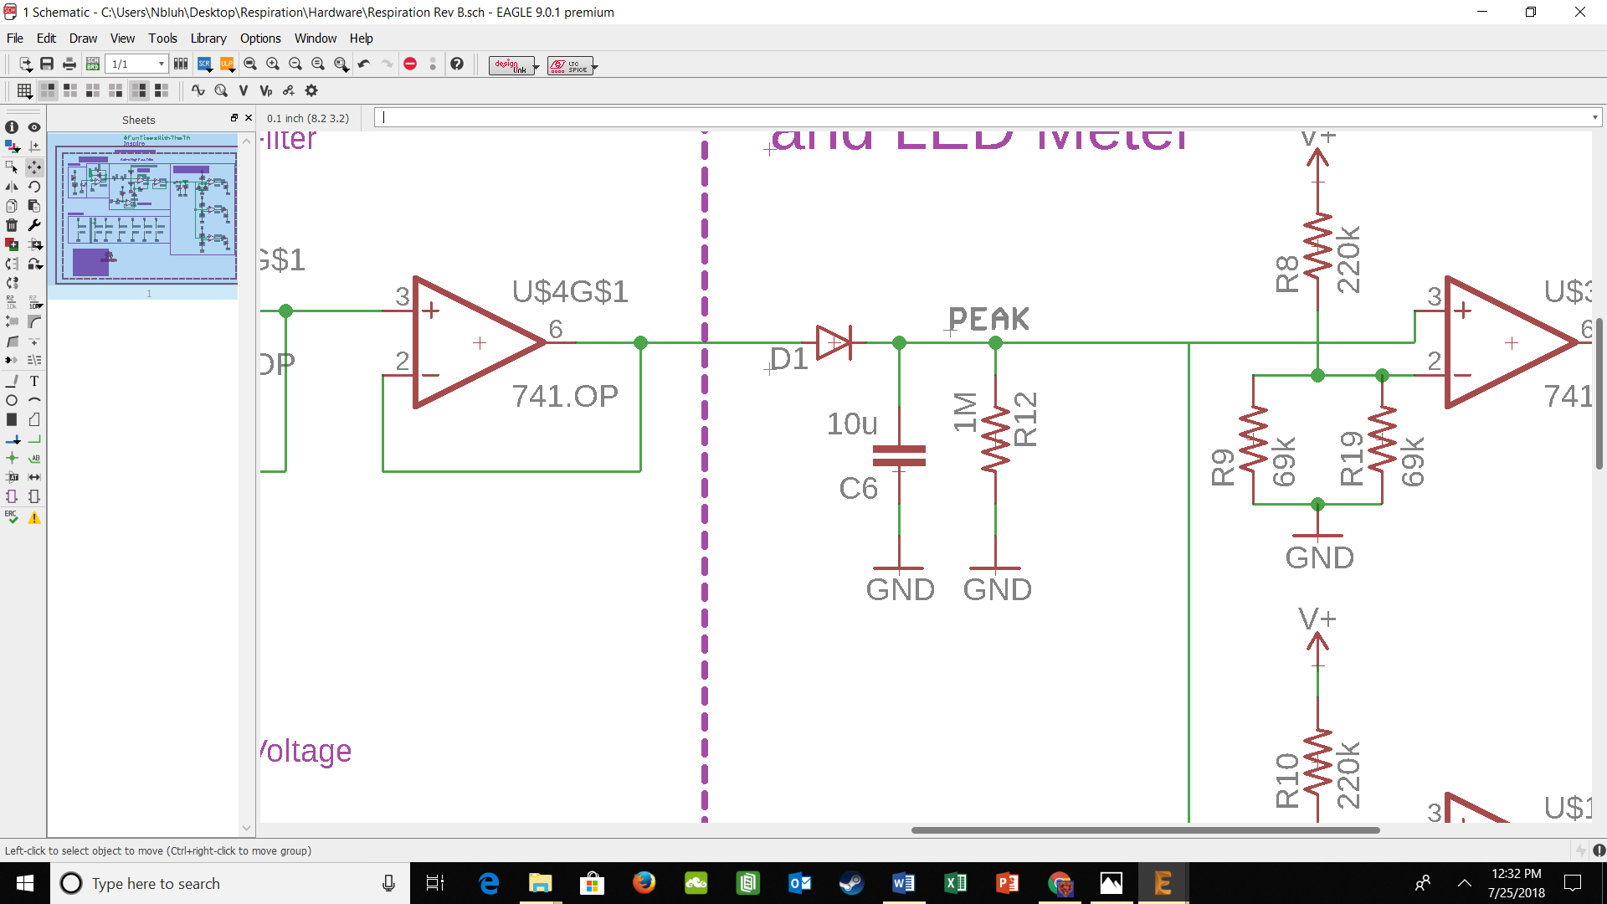

*Figure 6: Peak detector. The peak detector auto-adjusts to hold the peak value of the respiration signal*

***Adaptive Peak Detector Circuit***

As you noticed in Figure 1, our waveform has a peak which corresponds to inhalation. We will attempt to create a circuit that will automatically detect this peak and will blink an LED in response. The height of the respiration waveform’s predominant peak varies with a number of different factors. We would like our circuit to automatically adapt to these changes without additional intervention from the user. We will accomplish this with an adaptive peak detector.

A peak detector circuit, as the name suggests, finds the peak voltage of the input signal. It accomplishes this primarily with the diode and capacitor. A capacitor stores charge. If we were to connect a capacitor to a 9V battery, then remove the 9V battery, the voltage across the capacitor would remain 9V even with the battery removed. The peak detector utilizes this ability of the capacitor to measure the peak output voltage of our photoplethysmography circuit.

A diode only allows the flow of current in one direction (the direction the arrow is pointing). This prevents the capacitor from discharging. Essentially, this would mean that the capacitor would hold the 9V charge indefinitely. We do not want the capacitor to hold charge indefinitely, so we place a resistor in parallel with the capacitor. The resistor discharges the capacitor at a rate equal to the RC time constant (τ) of the resistor-capacitor circuit where,

$τ=R*C$ (4)

We set our RC time constant so that the capacitor holds the charge long enough to set a relatively level threshold with only small change in voltage before our next breath. With the RC circuit, we create an adaptive peak detector that can adjust its level based on the peak voltage of the respiration waveform.

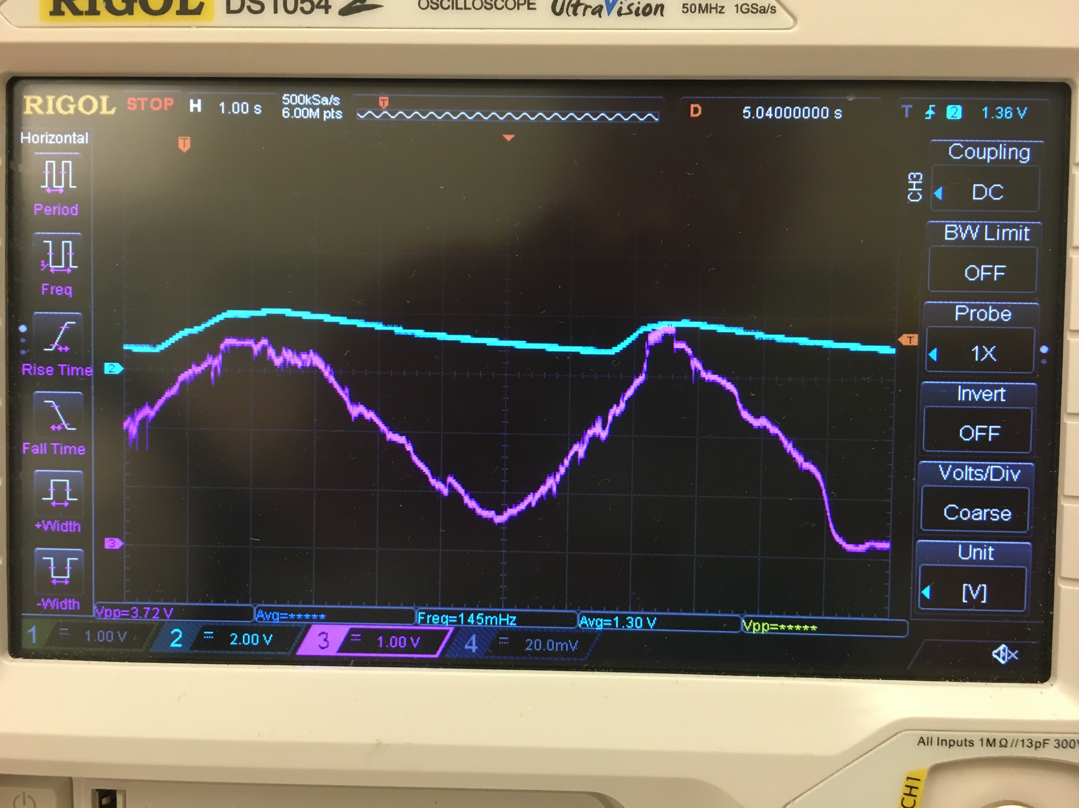

*Figure 7: Example output of Inspire highlighting the action of the adaptive peak detector in relation to the signal waveform. The blue line is the peak detector. The purple line is the respiration signal (Ignore the exact output voltages)*

***Comparator and LED indicator***



*Figure 8: Peak Detector and LED Meter Diagram*

A comparator compares the voltage between an op amp’s two inputs (inverting and non-inverting). The output of the comparator is determined by the following equation

$V_{out}=A_{OL}\left(V_{IN+}-V_{IN-}\right), with V^{-}≤Vout ≤V^{+}$ (5)

Where AOL is the open loop gain of the amplifier, which we will assume to be infinity, VIN+ is the voltage at the non-inverting pin, and VIN- is the voltage at the inverting pin. Do not confuse V+ and V-, which are the supply voltages of the op amp and VIN+ and VIN-, which are the voltages at the non-inverting and inverting input respectively. In short, if the voltage at VIN+ is higher than VIN-, the output of the amplifier will hit the positive rail (V+). If the voltage at VIN- is higher than VIN+, the output of the amplifier will hit the negative rail (V-).

To create the LED indicator, we connected the peak detector output to the non-inverting pin of the comparator and a bias voltage to the inverting pin. If the peak detector output voltage exceeds the voltage of the bias voltage, the output of the comparator is positive, which lights our LEDs indicating inhalation. If the peak detector does not exceed the voltage of the bias voltage, the LEDs will not light.

Instead of using 1 comparator, we send the output of the peak detector to 3 comparators. Each comparator has a different bias voltage (which is set using a voltage divider), which essentially sets a level needed to turn on the LED. This creates our “level meter” phenomenon.

Creating the proper thresholds for each level of the level meter takes a bit of work. I recommend observing the voltage of respiration signal, then setting three different levels, one voltage that every breath will trigger, one that requires a deeper breath, and one that requires a very deep breath. As a shorthand, you may try using 220kOhms as the upper resistor in the voltage divider and solving for the other resistor using the equation

$R=A_{OL}\left(V_{IN+}-V_{IN-}\right), with V^{-}≤Vout ≤V^{+}$ (5)

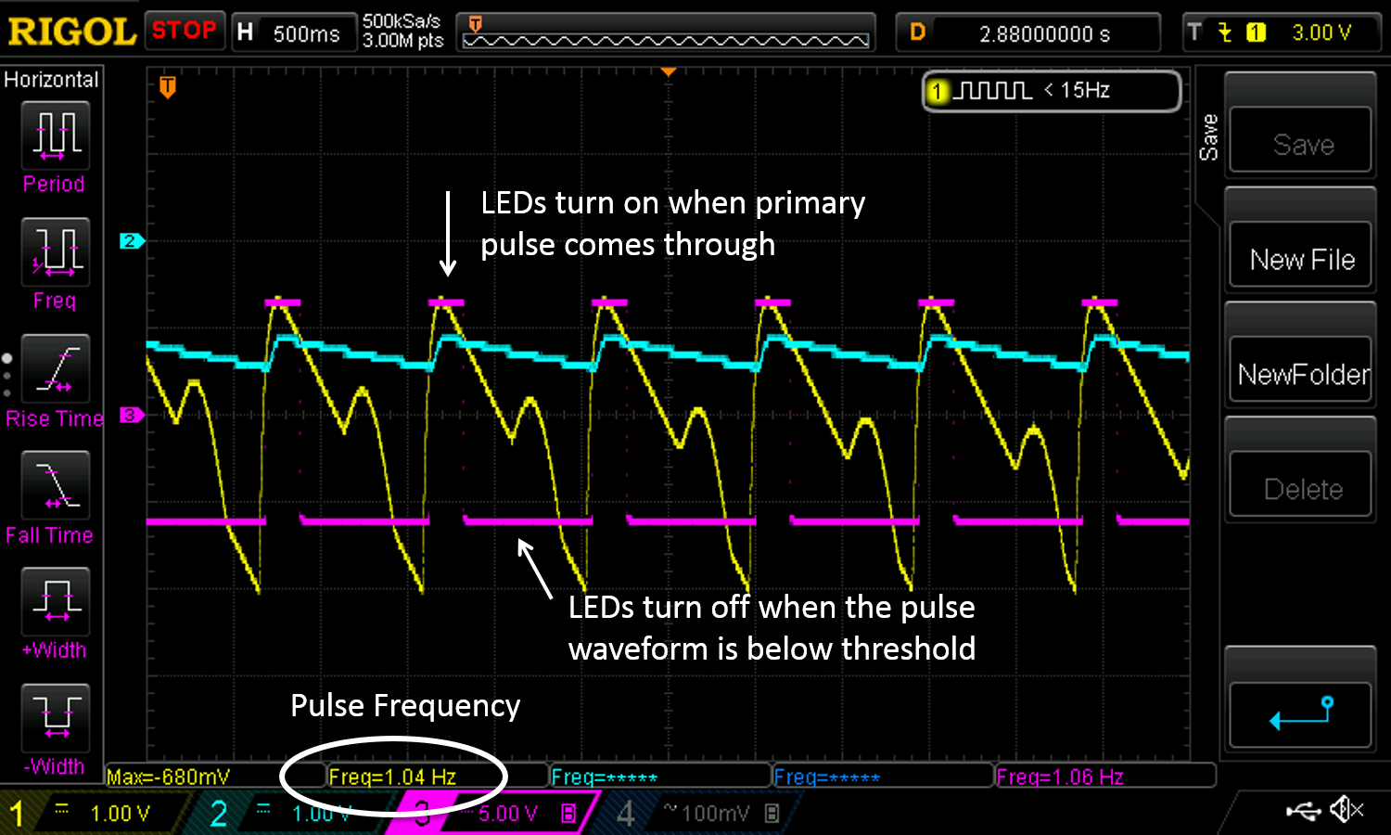

*Figure 9: Example output of Inspire highlighting the action of the adaptive peak detector in relation to the pulse waveform. Also showing the comparator output. Notice the comparator output voltage when the pulse waveform voltage is higher than the peak detector voltage. (Ignore the exact output voltages as this graph was obtained from a different circuit)*

***Testing***

1. Power the op amps with 5 V from the benchtop power supply
2. Output a 1 Hz, 5 Vpp sine waveform from the function generator and input it into the circuit just before the diode (feed the signal directly into the peak detector). The LED should pulse once a second.
3. View the sine wave, peak detector output, and comparator output on the oscilloscope. You should see outputs similar to Figure 9

***Try It!***

1. After you’ve had a little fun viewing the LED turning on and off, change the function generator output to 7 Vpp. You should see the peak detector output voltage adjust to the change in voltage and continue toggling the LED on and off after settling a bit.

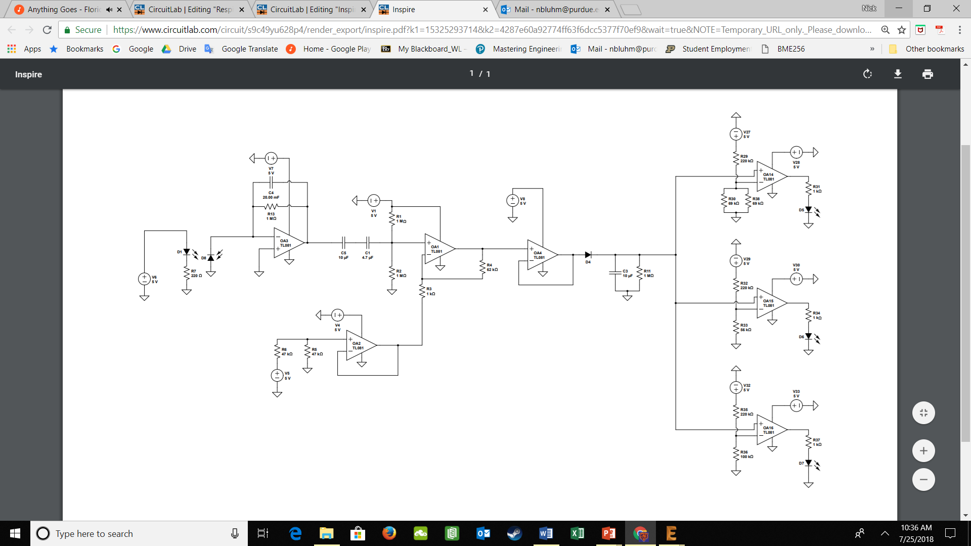

**Revision History**

|  |  |  |
| --- | --- | --- |
| **Revision Code** | **Revision**  **Date** | **Description** |
| A | 7/xx/2018 | * Initial document for second year of #FunTimesWithTheTA * Heavily adapted from Revision B of PulseFit #FunTimesWithTheTA |